**Planet Game UI**

Zoomed out view: this will be an overview of the planet as a whole

Clock:

The time will be displayed here. The game will be based on real world time, and certain creatures/items can only be collected at certain times of the day.

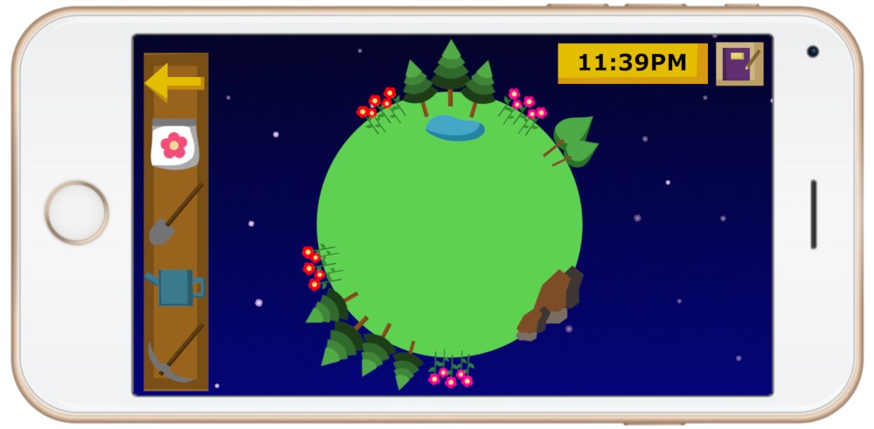

Inventory:

The player will have an inventory, which will be displayed in a bar on the left side of the screen.

Journal:

The player will have a journal which will list all of the collectible items in the game and will allow the player to keep track of how many different types of things they have discovered. There will also be a page in the journal displaying the planet name, date started and total time played.

Tools:

Seeds, etc may be displayed here along with tools which can be used to interact with the environment. For example, the player may have a watering can which allows them to stop plants from wilting for a certain amount of time. The player may also have an axe used to cut down trees they don’t want anymore and a pickaxe to collect minerals from rocks.

Zoomed in view: the player will be able to zoom into areas of their planet to get a clearer view of each section. From here, they will be able to collect items and creatures to fill their journal and use these items to unlock more things to place on their planet.

Return arrow

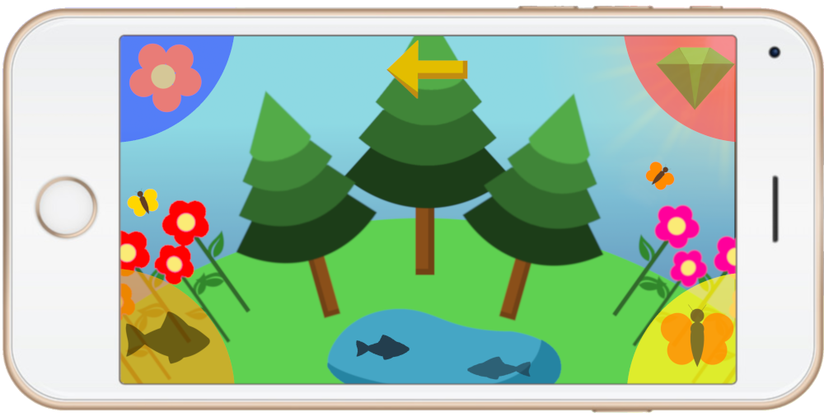

A menu will appear which allows the player to collect items, creatures, plants etc through a sorting mechanic. The player will need to tap and drag the collectibles into the appropriate category (displayed in each corner of the screen).